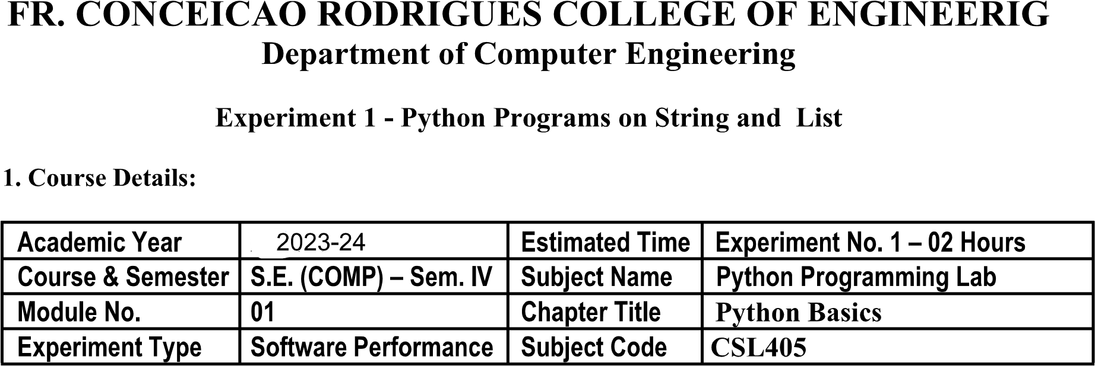

|  |  |  |  |  |  |  |  |  |
| --- | --- | --- | --- | --- | --- | --- | --- | --- |
|  | | Mark Lopes | | |  | | 9913 | |
|  | | 26/01/2024 | | |  | | 26/01/2024 | |
|  | |  | | | | | | |
|  |  | |  |  | |  | |  |
|  |  | |  |  | |  | |  |

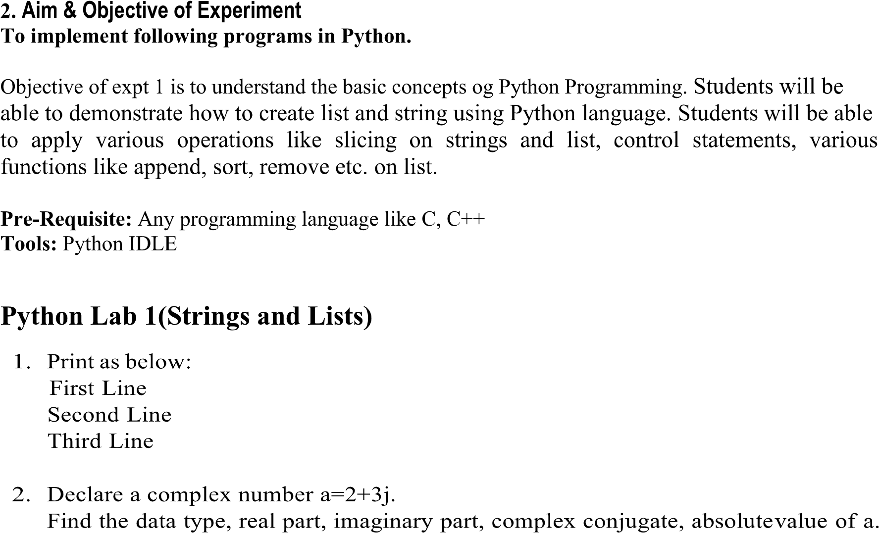

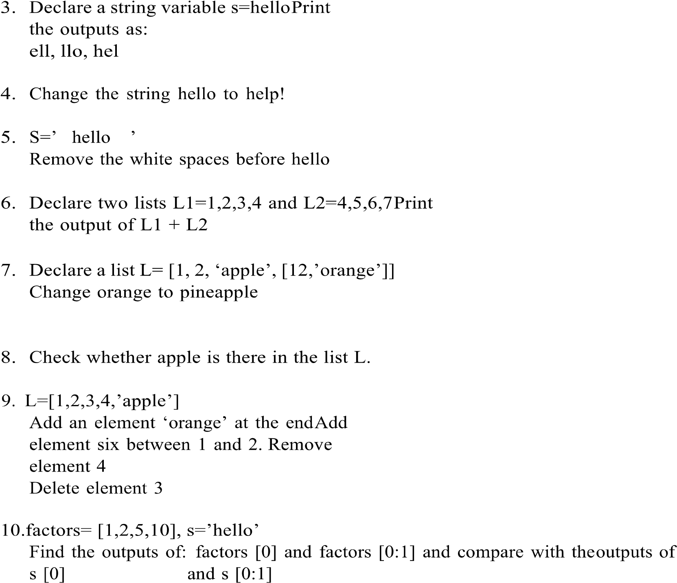

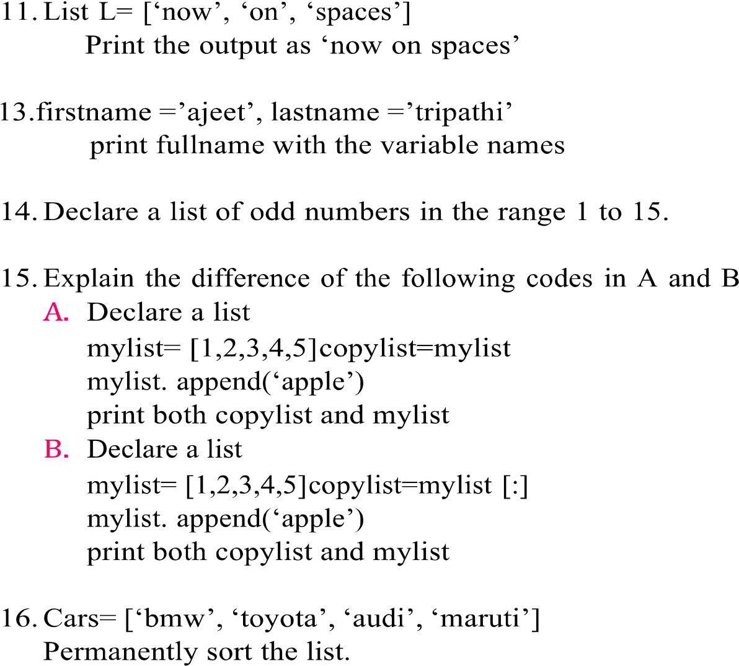

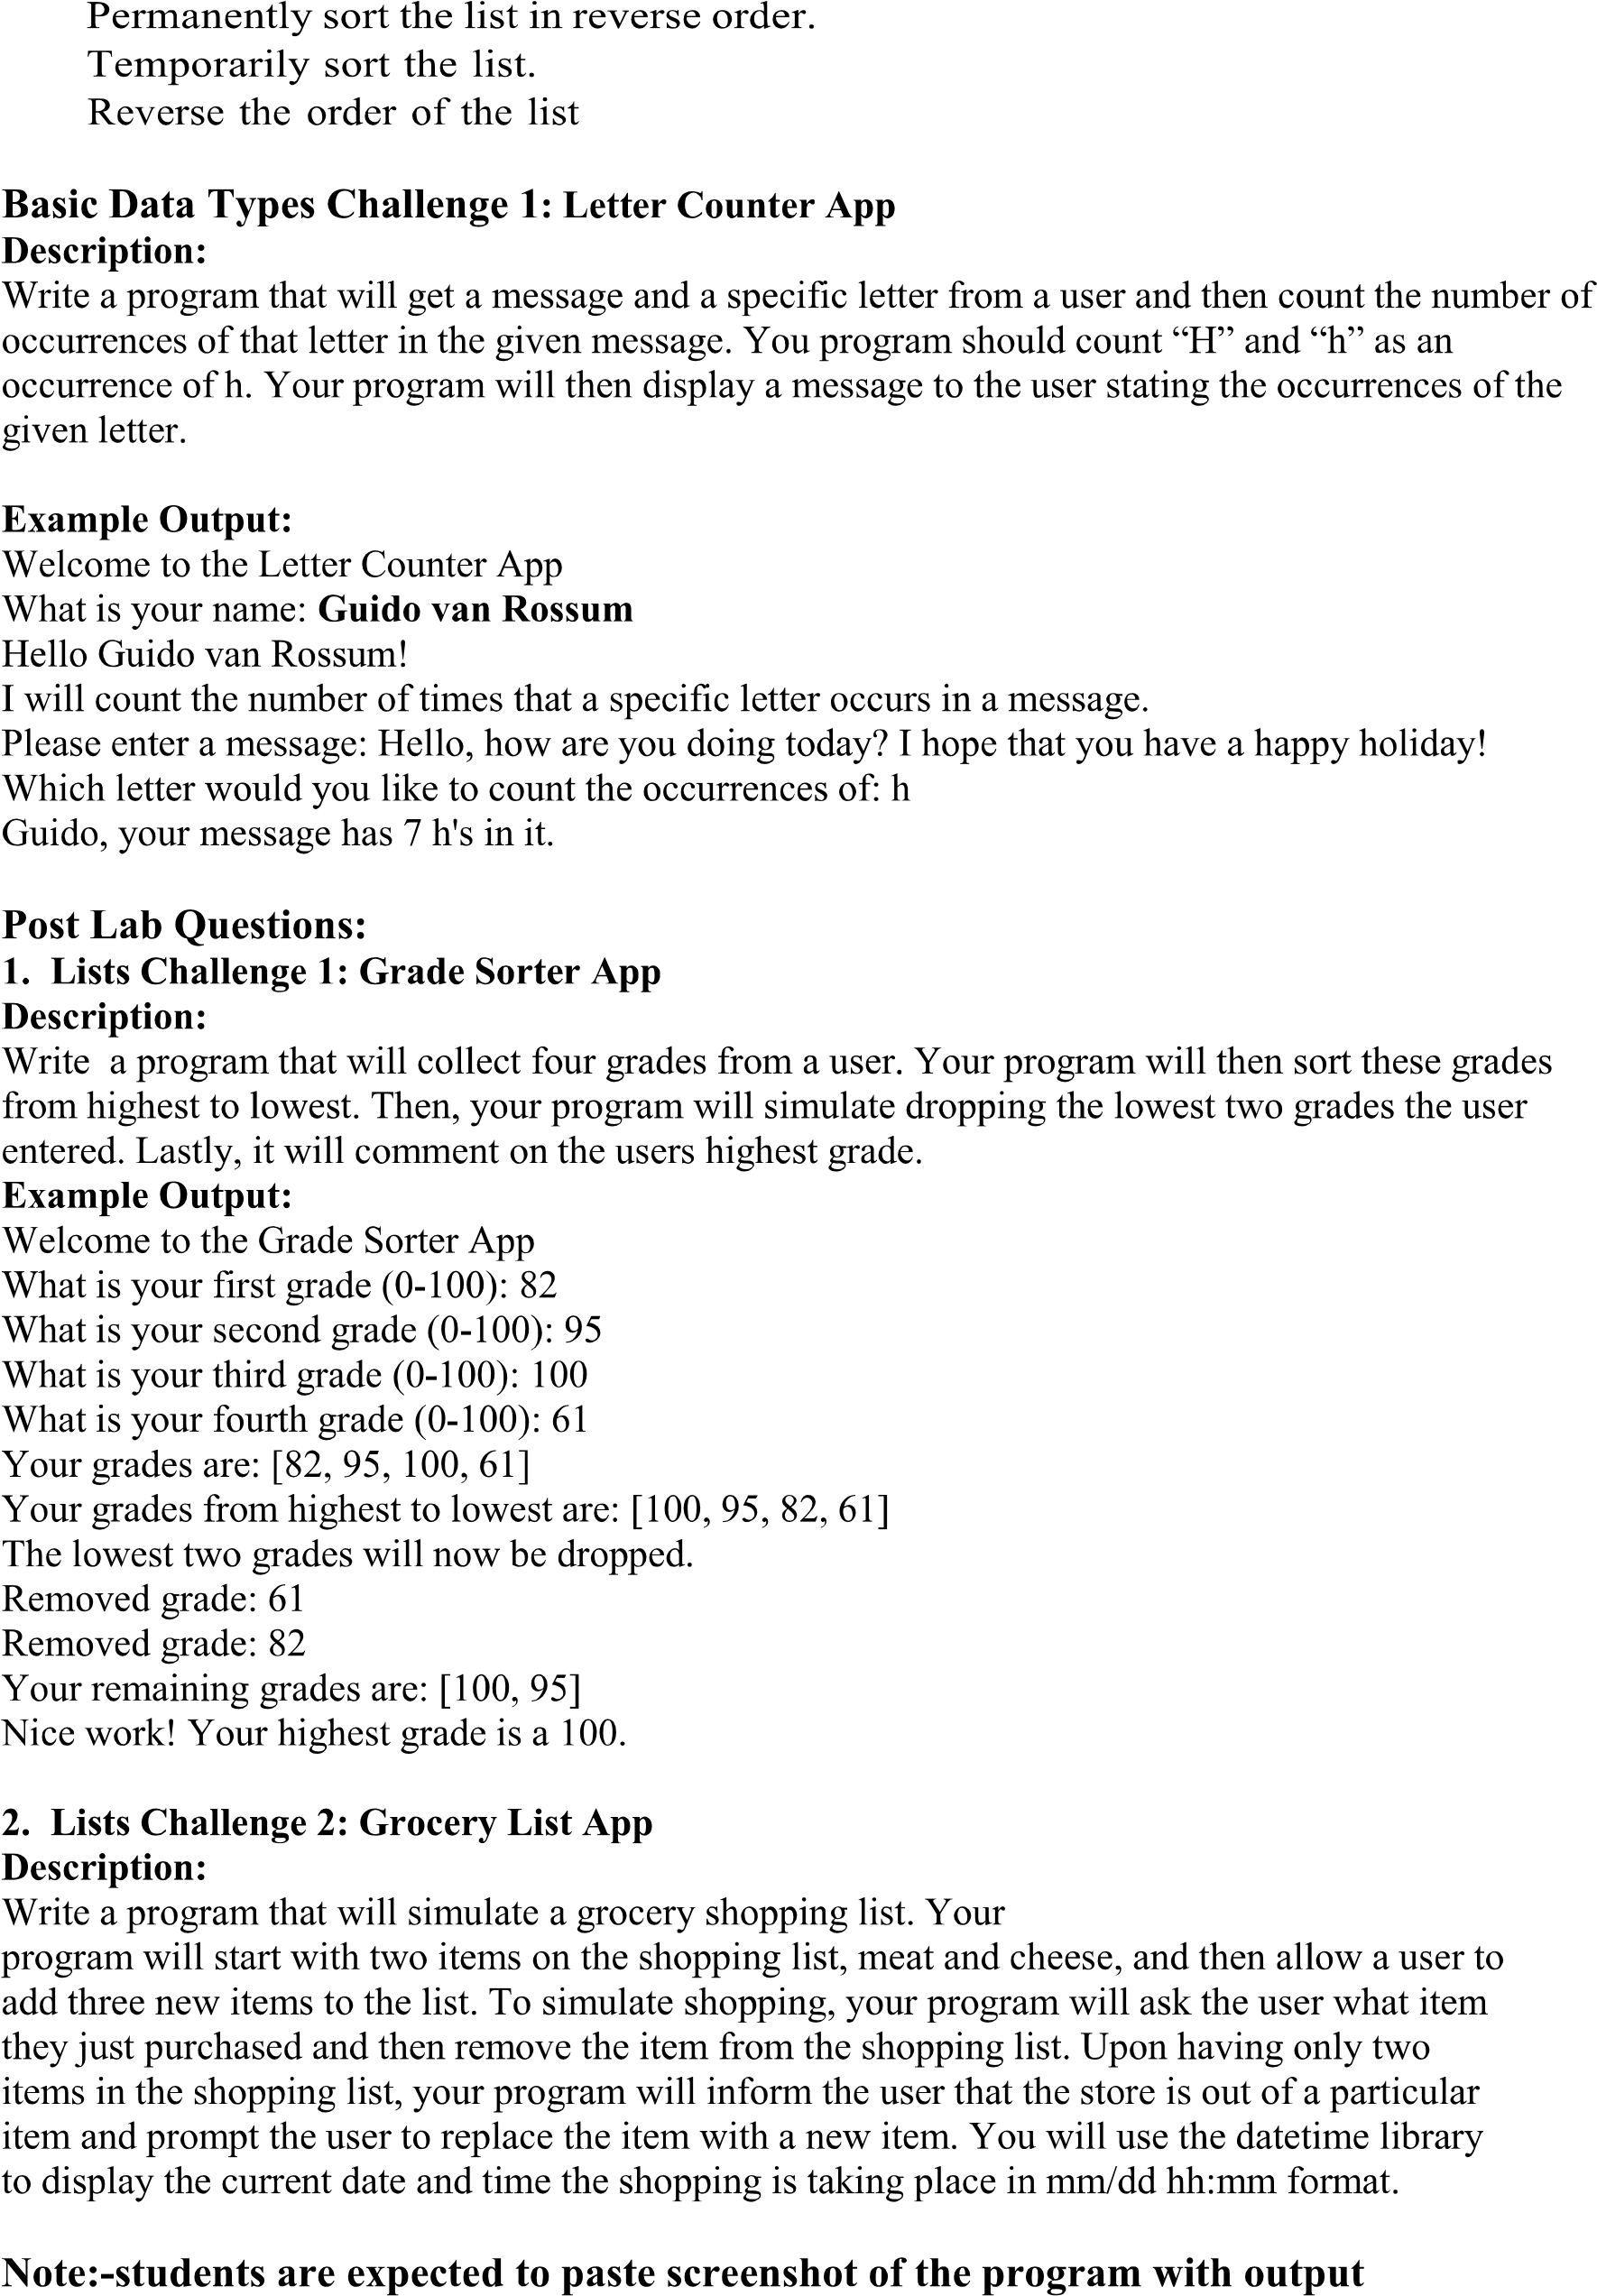

Q1.

print("First Line\nSecond Line\nThird Line")

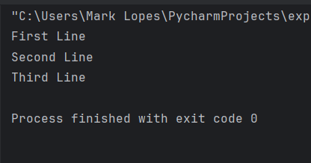

Q2.

import numpy  
a = 2+3j  
print(type(a))  
print(f"Real:{a.real}, Imaginary:{a.imag}")  
print(numpy.conj(a))  
print(abs(a))

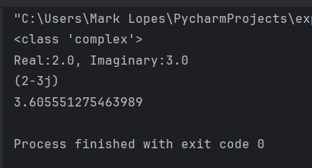

Q3.

s = "helloPrint"  
print(f"{s[1:4]}, {s[2:5]}, {s[0:3]}")

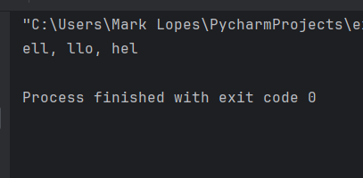

Q4.

string = 'hello'  
print(string.replace(string,"help!"))

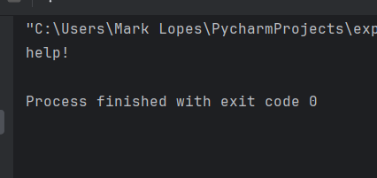

Q5.

S = ' hello '  
print(S.replace(" ",""))

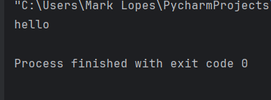

Q6.

L1 = [1,2,3,4]  
L2 = [4,5,6,7]  
print(L1+L2)

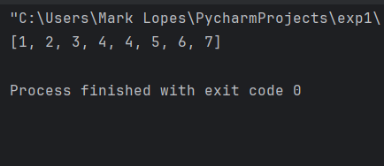

Q7

L = [1,2,'apple',[12,'orange']]  
L[3][1] = 'pineapple'  
print(L)

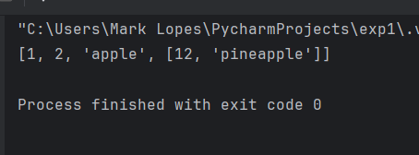

Q8.

L = [1,2,'apple',[12,'orange']]  
for item in L:  
 if item == 'apple':  
 print("apple is present")

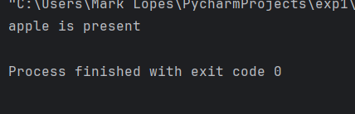

Q9.

L=[1,2,3,4,'apple']  
L.append('orange')  
print(L)  
L.insert(1,6)  
print(L)  
L.remove(4)  
print(L)  
L.remove(3)  
print(L)

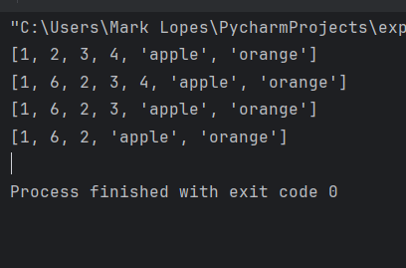

Q10.

factors= [1,2,5,10]  
s = 'hello'  
print(factors[0] == s[0])  
print(factors[0:1] == s[0:1])

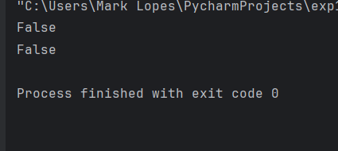

Q11

L= ['now', 'on', 'spaces']  
print(f"{L[0]} {L[1]} {L[2]}")

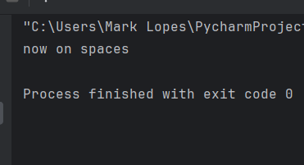

Q13.

firstname='ajeet'  
lastname='tripathi'  
print(f"firstname:{firstname} lastname:{lastname}")

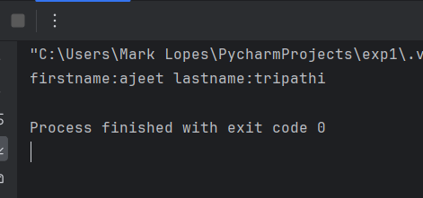

Q14.

odd_no = []  
for i in range(1,15):  
 if i%2!= 0:  
 odd_no.append(i)  
  
print(odd_no)

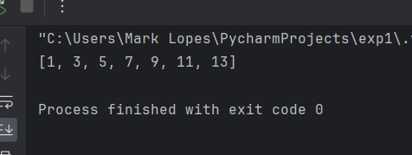

Q15.

mylist= [1,2,3,4,5]  
copylist=mylist  
mylist.append('apple')  
print(mylist)  
print(copylist)

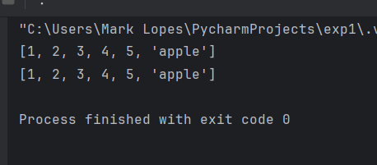

mylist= [1,2,3,4,5]  
copylist=mylist[:]  
mylist.append('apple')  
print(mylist)  
print(copylist)

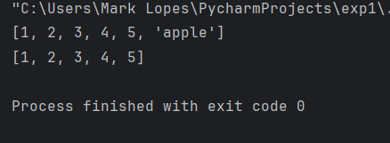

Q16.

Cars=['bmw', 'toyota', 'audi', 'maruti']  
#sort permanent  
Cars.sort()  
print(Cars)  
#reverse permanent  
Cars.reverse()  
print(Cars)  
#temporary sort  
Cars_sort = sorted(Cars)  
print(Cars_sort)  
#reverse temporary  
print(Cars[::-1])

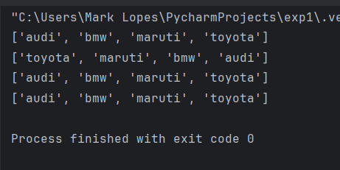

**Challenge_1:-**

def count_occurrences(message, letter):  
 message = message.lower()  
 letter = letter.lower()  
 count = message.count(letter)  
 return count  
  
  
print("Welcome to the Letter Counter App")  
user_name = input("What is your name: ")  
print(f"Hello {user_name}!")  
  
print("I will count the number of times that a specific letter occurs in a message.")  
message = input("Please enter a message: ")  
letter = input("Which letter would you like to count the occurrences of: ")  
  
result = count_occurrences(message, letter)  
  
print(f"{user_name}, your message has {result} {letter}'s in it.")

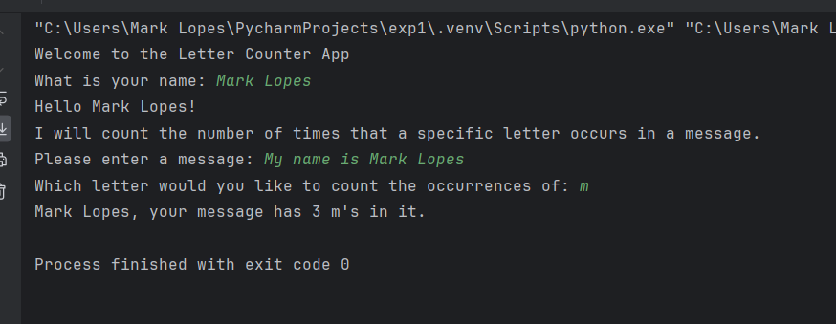

**Postlab_1:-**

print("Welcome to the Grade Sorter App")  
  
grades = []  
for i in range(1, 5):  
 grade = int(input(f"What is your {i} grade (0-100): "))  
 grades.append(grade)  
  
print("\nYour grades are:", grades)  
  
grades.sort()  
grades.reverse()  
print("Your grades from highest to lowest are:", grades)  
  
grades_drop = grades[-2:]  
  
for bye_grade in grades_drop:  
 print(f"Removed grade: {bye_grade}")  
  
print("\nYour remaining grades are:", grades[:-2])  
  
  
print(f"Nice work! Your highest grade is a {max(grades)}.")

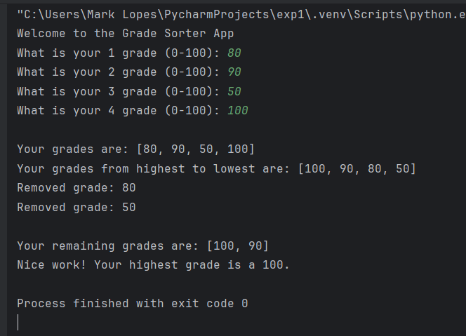

**Postlab_2:-**

from datetime import datetime  
  
  
def display_list(items):  
 print("\nCurrent Shopping List:")  
 for item in items:  
 print(f"- {item}")  
 print()  
  
  
shopping_list = ["vada pav", "biryani"]  
  
display_list(shopping_list)  
  
for i in range(3):  
 new_item = input("Add a new item to the shopping list: ")  
 shopping_list.append(new_item)  
  
display_list(shopping_list)  
  
for i in range(3):  
 purchased_item = input("What item did you just purchase? ")  
 try:  
 shopping_list.remove(purchased_item)  
 print(f"{purchased_item} removed from the shopping list.")  
 except ValueError:  
 print(f"Sorry, {purchased_item} is not in the shopping list. Please check your input.")  
  
 display_list(shopping_list)  
  
out_of_item = shopping_list.pop()  
print(f"\nThe store is out of {out_of_item}. Please replace it with a new item.")  
replacement_item = input("Enter the replacement item: ")  
shopping_list.append(replacement_item)  
  
display_list(shopping_list)  
  
current_time = datetime.now().strftime("%m/%d %H:%M")  
print(f"\nShopping completed on {current_time}.")

